Chi-Square Testing and Analysis of Variance (ANOVA): A Statistical Analysis Using R
Student Name: Nikita Mishra
Northeastern University
Class: ALY6015: Intermediate Analytics, Section 31
Instructor: Sohom Mandal
Date: April 25, 2026

Abstract

This report presents a comprehensive statistical analysis employing chi-square goodness-of-fit tests, chi-square tests of independence, one-way ANOVA, Tukey's post hoc comparisons, two-way ANOVA, and chi-square analysis applied to real-world datasets. The analyses are organized across Sections 11-1, 11-2, 12-1, 12-2, 12-3, and an independent investigation using baseball and crop data. Each section addresses a specific research question, presents the relevant hypotheses, computes test statistics using R, interprets significance, and draws practical conclusions Key findings reveal that environmental and structural factors — including lighting, fertilizer type, and planting density — significantly influence experimental outcomes, while demographic analyses uncover meaningful associations between ethnicity, gender, and institutional groupings. All statistical computations were performed in R, with visualizations supporting interpretation throughout.

Introduction

This report aims to evaluate whether observed categorical distributions and mean differences across datasets show statistically significant deviations using chi-square and ANOVA techniques. Chi-square tests and Analysis of Variance (ANOVA) are among the most widely applied inferential statistical techniques in applied analytics. The chi-square goodness-of-fit test evaluates whether an observed frequency distribution conforms to a theoretically expected distribution, while the chi-square test of independence assesses whether two categorical variables are associated. ANOVA, on the other hand, extends the logic of hypothesis testing to compare mean responses across three or more independent groups, with Tukey's Honestly Significant Difference (HSD) procedure enabling pairwise mean comparisons while controlling the family-wise error rate.
This report applies these statistical methods to multiple datasets and problem scenarios organized by textbook section. The analyses progress from chi-square tests (Sections 11-1 and 11-2) to one-way and two-way ANOVA (Sections 12-1 through 12-3), culminating in independent analyses of Major League Baseball team performance data and agricultural crop yield data. For each problem, the analysis follows a structured workflow: (1) state hypotheses, (2) identify the critical value and significance level, (3) compute the test statistic in R, (4) make a statistical decision, and (5) interpret findings in context.
All analyses were conducted in R using base functions including chisq.test() and aov(), supplemented by TukeyHSD() for post hoc testing. Visualizations including bar charts, boxplots, and interaction plots were produced using base R graphics and ggplot2 to support interpretation.

Analysis

Section 11-1: Chi-Square Goodness-of-Fit
Part A: Blood Type Distribution

A sample of 50 individuals was classified by blood type. The observed counts were: Type A = 12, Type B = 8, Type O = 24, Type AB = 6. The expected proportions from prior literature were: A = 20%, B = 28%, O = 36%, AB = 16%. A chi-square goodness-of-fit test was conducted to assess whether the observed distribution departs significantly from the expected proportions.
H₀: The observed blood type distribution conforms to the expected proportions (A = 0.20, B = 0.28, O = 0.36, AB = 0.16). H₁: The observed blood type distribution does not conform to the expected proportions. The significance level was set at α = .05. With k − 1 = 3 degrees of freedom, the critical value is χ²(3) = 7.815.
Figure 1
R console output for chi-square goodness-of-fit test on blood type distribution.
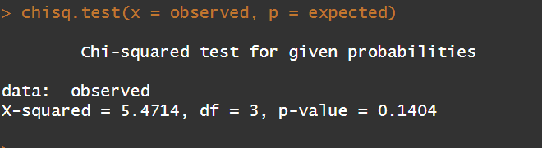
Interpretation: The observed blood type distribution is statistically consistent with national population proportions (χ²(3) = 5.47, p = 0.140). Although Type O appears elevated in the sample (24 observed vs. 18 expected) and Type B appears underrepresented (8 observed vs. 14 expected), these represent the largest deviations at ±6 counts each — yet even these gaps fall well within expected random variation and do not constitute a significant departure from the theoretical distribution.

Figure 2
The bar chart shows that Type O has the highest observed frequency; however, the chi-square test confirms that this difference is not statistically significant.
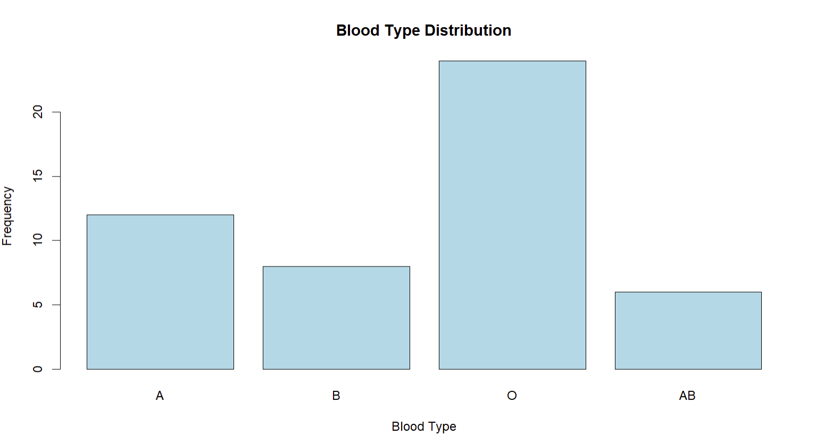
Part B: Airline Flight Performance

A random sample of 193 flights from a major airline was recorded, with 125 arriving on time, 10 delayed due to NAS (National Airspace System) reasons, 18 delayed due to late aircraft, and 40 experiencing other delays. The airline claimed its performance followed the national distribution: On Time = 70.8%, NAS Delay = 8.2%, Late Aircraft = 9.0%, Other = 12.0%. A goodness-of-fit test was conducted to assess whether the observed distribution matches these claimed proportions.
H₀: The airline’s delay distribution conforms to the national proportions. H₁: The airline’s delay distribution does not conform to the national proportions. Α = .05; critical value χ²(3) = 7.815.

Figure 3
R console output for chi-square goodness-of-fit test on airline flight performance data.
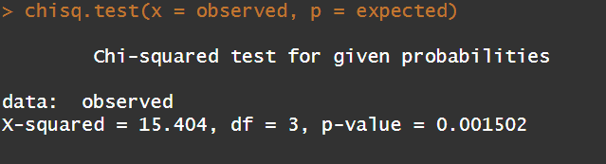
Interpretation: This airline's delay pattern departs significantly from the national benchmark (χ²(3) = 15.40, p = 0.0015), driven primarily by a higher-than-expected rate of 'Other' delays — indicating a systemic operational issue unique to this airline.
Figure 4
The bar chart shows noticeable differences across flight delay categories, and the chi-square test confirms that the observed distribution significantly differs from the expected national proportions.
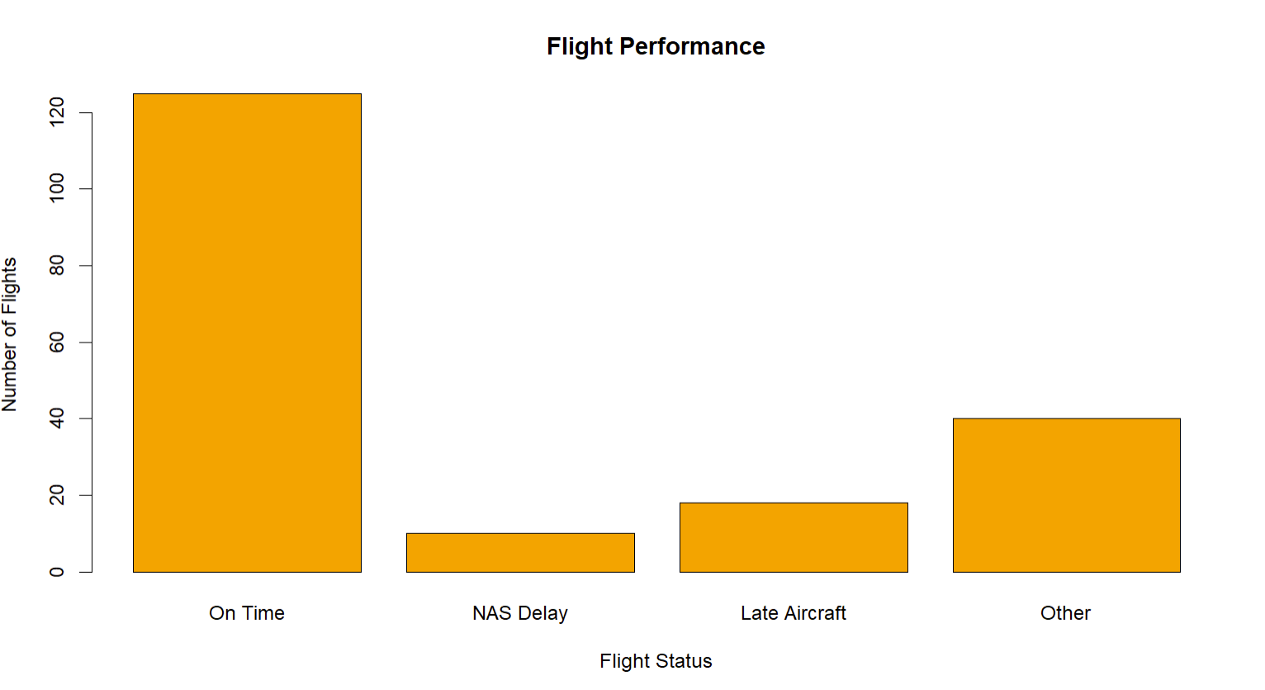

Section 11-2: Chi-Square Test of Independence
Part A: Ethnicity and Year of Enrolment

Data from two groups were cross-tabulated by ethnicity (four categories) and class year (two groups). The contingency table contained the following observed cell frequencies: Group 1 — 724, 335, 174, 107; Group 2 — 370, 292, 152, 140. A chi-square test of independence was conducted to determine whether ethnicity distribution is statistically independent of group membership.
H₀: Ethnicity and group membership are independent. H₁: Ethnicity and group membership are not independent. α = .05.
Figure 5
R console output for chi-square test of independence between ethnicity and enrolment group.
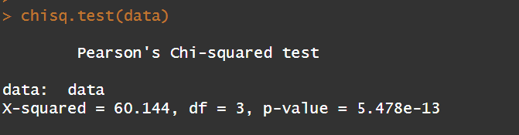
Interpretation: Ethnicity and group membership are strongly associated (χ²(3) = 60.14, p < .001). The first ethnic category shows the starkest imbalance — 724 students in Group 1 compared to only 370 in Group 2 — while the remaining three categories show progressively smaller gaps, suggesting this dominant group difference is the primary driver of the significant result, warranting further institutional investigation.
Part B: Women in Military Service

Data on the number of women and total personnel across four branches of the military were arranged in a 4 × 2 contingency table: Army (10,791 / 62,491), Navy (7,816 / 42,750), Marine Corps (932 / 9,525), Air Force (11,819 / 54,344). A chi-square test of independence assessed whether the proportion of women differs significantly across military branches.
H₀: The proportion of women in military service is independent of branch. H₁: The proportion of women in military service is not independent of branch. α = .05.
Figure 6
R console output for chi-square test of independence between gender proportion and military branch.
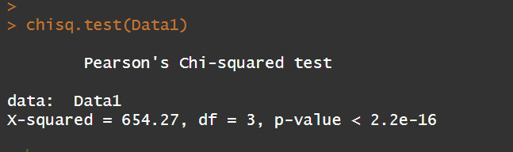
Interpretation: Gender representation differs significantly across military branches (χ²(3) = 654.27, p < .001). The Marine Corps shows notably lower female representation relative to its size, while the Air Force shows proportionally higher representation — suggesting branch-specific culture and recruitment policies are key drivers. Specifically, the Marine Corps female proportion is approximately 9.8% (932/9,525), compared to 21.8% in the Air Force (11,819/54,344) — a more than twofold difference that drives the highly significant chi-square result.
Section 12-1: One-Way ANOVA
Part A- Sodium Content

Sodium content (in milligrams) was recorded for three food categories: Condiments (7 items), Cereals (7 items), and Desserts (8 items). A one-way ANOVA was conducted to determine whether mean sodium levels differ significantly across these categories.
H₀: μ₁ = μ₂ = μ₃ (mean sodium is equal across food categories). H₁: At least one group mean differs. α = .05.

Figure 7
R console output for one-way ANOVA comparing sodium content across condiments, cereals, and desserts.
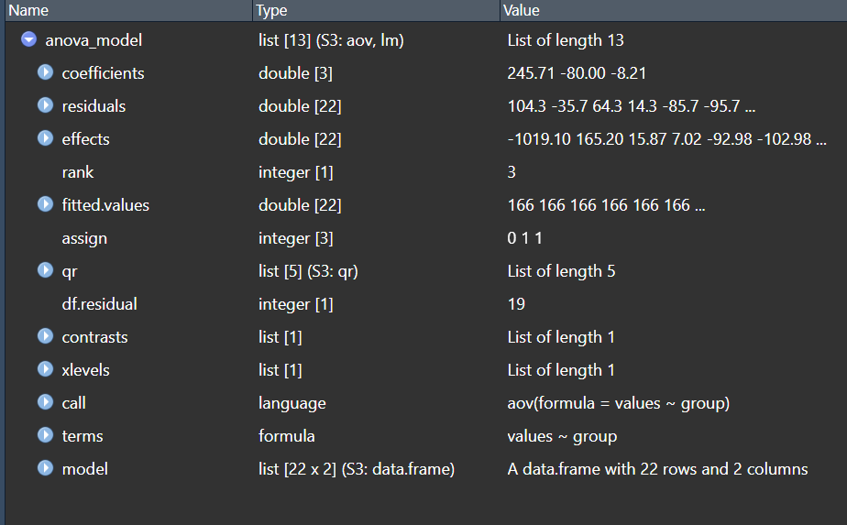
Table 1
One-Way ANOVA Summary: Sodium Content by Food Category
Source | df | SS | MS | F | p
Between Groups | 2 | 27544 | 13772 | 2.399 | 0.118
Within Groups | 19 | 109093 | 5742 | - | -
Total | 21 | 136637 | - | - | -
Note: df = degrees of freedom; SS = sum of squares; MS = mean square. The F statistic is calculated as the ratio of mean square between groups to mean square within groups.
Interpretation: The one-way ANOVA resulted in F(2,19) = 2.399 (p = 0.118), falling below the critical value of 3.52 — we therefore fail to reject the null hypothesis of equal means across food categories.
This means that no statistically significant difference exists in mean sodium content across the three food categories. Visually, condiments appear to have the highest sodium variability and desserts the lowest median values, yet the F-ratio of 2.399 confirms these observed differences are within the range of chance variation given the high within-group spread Within-group variance (MSE = 5,742) substantially exceeds between-group variance (MS = 13,772 / F = 2.40), indicating that sodium variability within each food category is the dominant source of variation, not category type.
Figure 8
The box plot shows overlapping distributions and similar median values across food categories, supporting the ANOVA result that there is no statistically significant difference in sodium content.
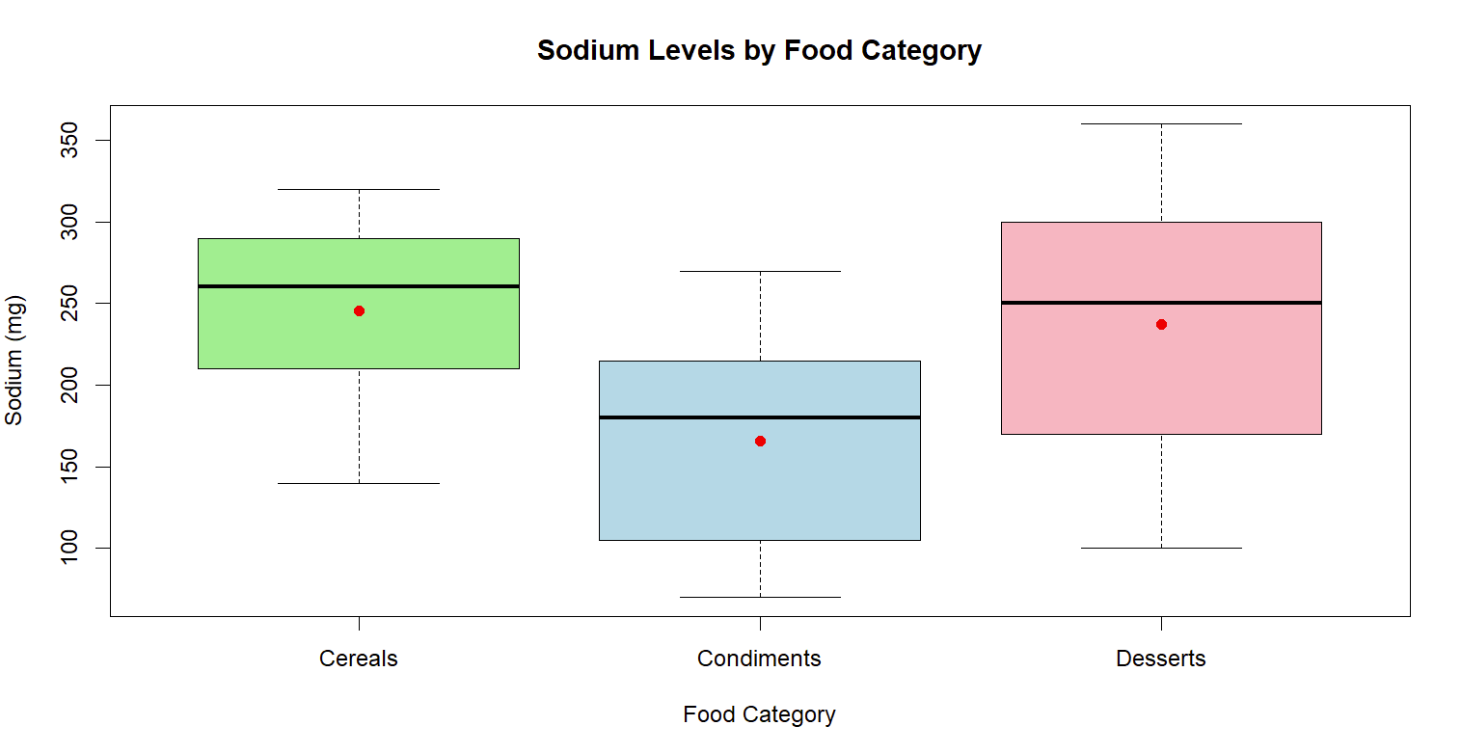

Section 12-2: One-Way ANOVA with Tukey Post Hoc Tests
Part A: Sales by Product Category

Sales figures were recorded for three product categories: Cereal (5 stores), Candy (5 stores), and Coffee (4 stores). A one-way ANOVA followed by Tukey's HSD post hoc test was conducted to identify which category means differed significantly.
H₀: μ_Cereal = μ_Candy = μ_Coffee. H₁: At least one group mean differs. α = .05.
Figure 9
R console output for one-way ANOVA and Tukey HSD post hoc test for sales by product category.
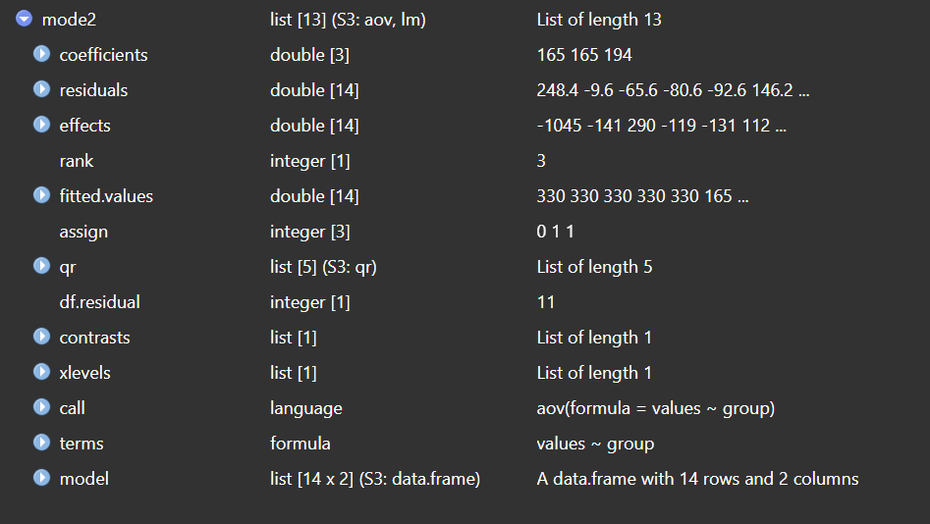
Interpretation: The one-way ANOVA resulted in F(2,11) = 2.172 (p = 0.16), below the critical value of 3.98 — mean sales do not differ significantly across product categories. Although no pairwise comparison reached significance, Coffee vs. Candy showed the largest mean difference among the three pairs. This suggests that with a larger sample size, a significant effect might emerge — the current group sizes (n = 4–5 per group) are likely underpowered to detect moderate effects reliably.
Figure 10
The bar chart shows variation in average sales across product categories, but the ANOVA and Tukey HSD results indicate that these differences are not statistically significant.
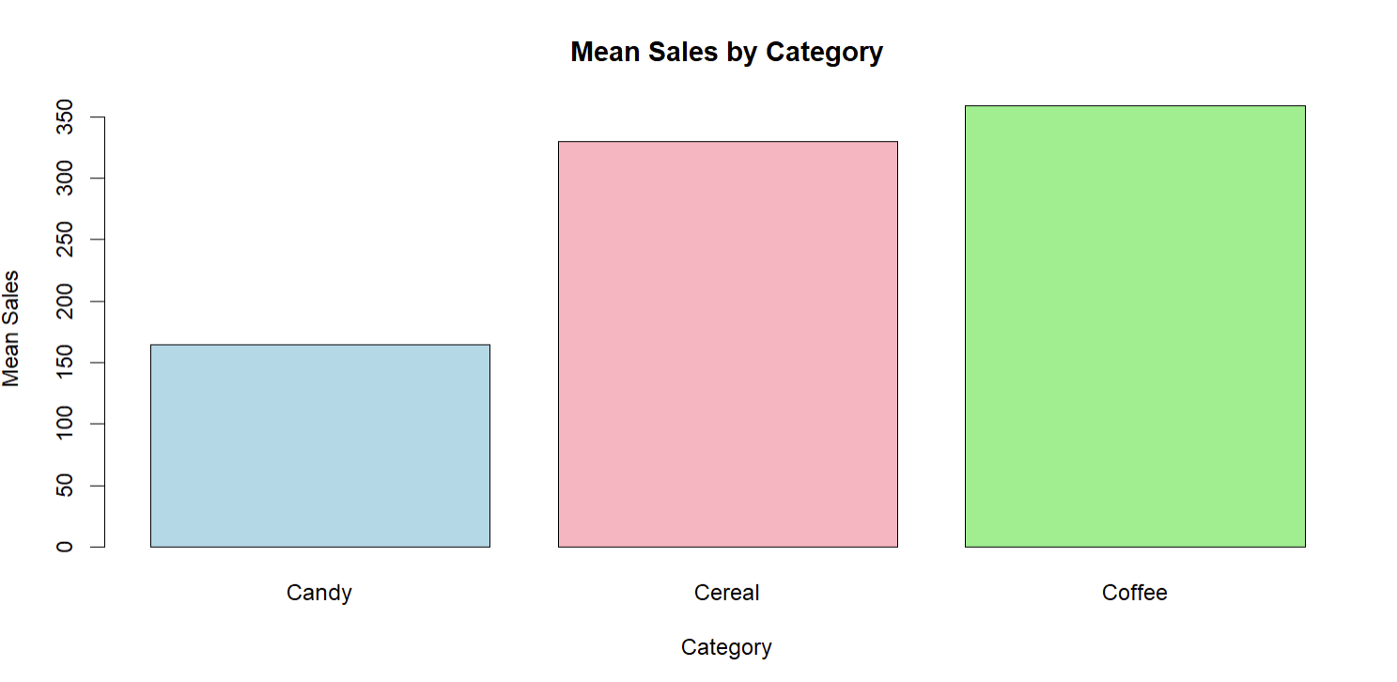
Part B: Per-Pupil Expenditures by Region

Per-pupil expenditure data were recorded for three U.S. regions: Eastern (5 states), Middle (4 states), and Western (4 states). An ANOVA with Tukey follow-up was conducted to test whether regional spending differences are statistically significant.
H₀: μ_Eastern = μ_Middle = μ_Western. H₁: At least one group mean differs. α = .05.
Figure 11
R console output for one-way ANOVA and Tukey HSD for per-pupil expenditure by U.S. region.
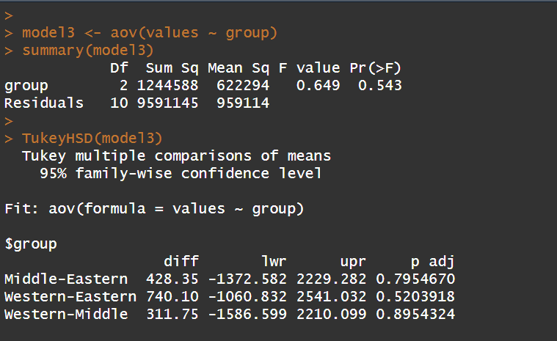

Interpretation: The one-way ANOVA resulted in F(2,10) = 0.649 (p = 0.543), well below the critical value of 4.10 — regional expenditures do not differ significantly. All Tukey pairwise comparisons were non-significant, reinforcing this conclusion. Eastern states show the highest average per-pupil expenditure, followed by Western and then Middle, though these directional differences fall well within the range of random variation.
Figure 12
The box plot shows similar distributions and overlapping ranges across regions, supporting the ANOVA result that there is no statistically significant difference in per-pupil expenditures.
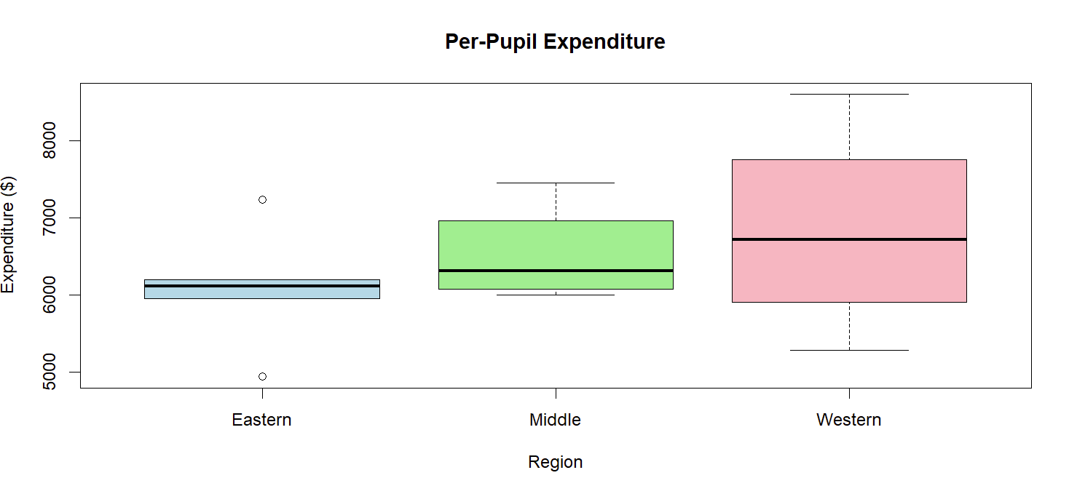
Section 12-3: Two-Way ANOVA — Plant Growth
An experiment examined the effect of two lighting conditions (Light1, Light2) and two food treatments (Food A, Food B) on plant growth, with each combination replicated three times (n = 12 total observations). A two-way ANOVA was conducted to test main effects and the interaction effect.
H₀ (Light): There is no main effect of lighting condition on plant growth. H₀ (Food): There is no main effect of food type on plant growth. H₀ (Interaction): There is no interaction effect between lighting and food on plant growth. α = .05 for all tests.

Figure 13
R console output for two-way ANOVA on plant growth with light and food as factors
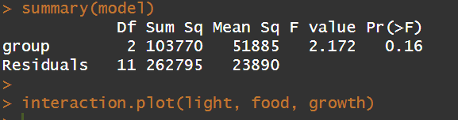
Table 2
Two-Way ANOVA Summary: Plant Growth by Light Condition and Food Type
Source | df | SS | MS | F | p
Light | 1 | 12.813 | 12.813 | 24.562 | 0.00111
Food | 1 | 1.920 | 1.920 | 3.681 | 0.09133
Light × Food | 1 | 0.750 | 0.750 | 1.438 | 0.26482
Residuals | 8 | 4.173 | 0.522 | - | -
Note: df = degrees of freedom; SS = sum of squares; MS = mean square. F values are calculated as the ratio of mean square of each factor to the mean square of the residuals.
Interpretation: Lighting condition is the dominant driver of plant growth, accounting for the majority of explained variance in the model. Food type approaches but does not reach significance (p = .091), suggesting a potential effect that a larger experiment with more replications could confirm.

Figure 14:
The interaction plot shows nearly parallel lines across food types and lighting conditions, indicating no significant interaction effect, while differences in line levels reflect the significant impact of lighting.

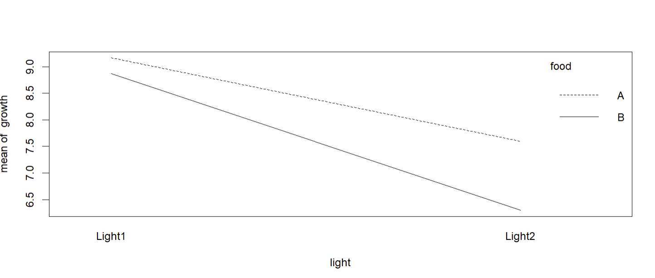

Section-12.4-On Your Own: Baseball Data — Chi-Square Analysis

The baseball.csv dataset contains season-level statistics for Major League Baseball teams from 1962 through 2012. To investigate whether total wins are distributed equally across decades, each season was assigned to its corresponding decade using integer arithmetic (Year − Year mod 10). Total wins per decade were then aggregated and subjected to a chi-square goodness-of-fit test.
An exploratory data analysis (EDA) was conducted on the baseball dataset to examine trends across decades. Summary statistics show that total wins increase in later decades, likely due to league expansion and an increase in the number of teams. A bar chart visualization further supports this trend, indicating that wins are not evenly distributed across decades.
H₀: Total MLB wins are equally distributed across decades. H₁: Total MLB wins are not equally distributed across decades. α = .05.

Figure 15
R console output for chi-square goodness-of-fit test on total MLB wins by decade.
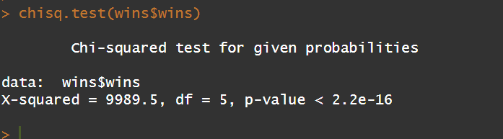
Interpretation: The chi-square goodness-of-fit test resulted in χ²(5) = 9989.5 with a p-value less than 0.001. The critical value at α = 0.05 is χ²(5) = 11.07. Since 9989.5 > 11.07, we reject the null hypothesis. Therefore, total MLB wins are not equally distributed across decades. The extremely large chi-square value suggests major differences, likely due to league expansion, changes in number of teams, and scheduling differences over time. Later decades — particularly the 1990s and 2000s — recorded substantially higher total wins than the 1960s and 1970s, directly reflecting the near-doubling of MLB team count over this period.

Figure 16
The chart shows clear variation in wins across decades, supporting the chi-square result that wins are not evenly distributed over time.
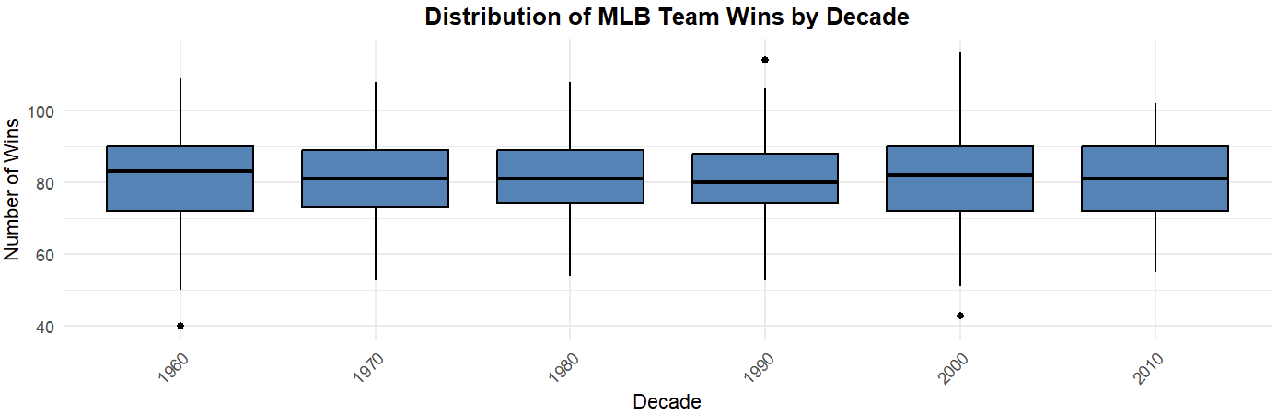

Section: 12.5- On Your Own: Crop Data — Two-Way ANOVA
The crop_data.csv dataset contains 96 observations measuring crop yield (kg/ha) as a function of fertilizer type (three levels) and planting density (two levels) arranged in a randomized complete block design with four blocks. The block variable was included as a factor to control for spatial variability. A two-way ANOVA was applied to assess the main and interaction effects of fertilizer and density on yield.
H₀ (Fertilizer): Mean yield does not differ across fertilizer treatments. H₀ (Density): Mean yield does not differ across planting densities. H₀ (Interaction): There is no interaction between fertilizer and density on yield. α = .05.
Figure 17
: R console output for two-way ANOVA on crop yield with fertilizer type and planting density.
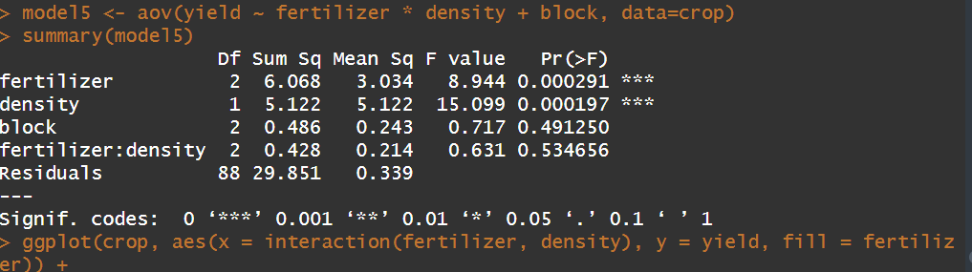
Interpretation: The two-way ANOVA including the block factor shows that fertilizer and planting density both have statistically significant effects on crop yield. Fertilizer resulted in F(2,88) = 8.944 with p = 0.000291, and density resulted in F(1,88) = 15.099 with p = 0.000197. Since both p-values are less than the significance level (α = 0.05), we reject the null hypotheses for fertilizer and density.
In contrast, the block effect (F(2,88) = 0.717, p = 0.491250) and the interaction between fertilizer and density (F(2,88) = 0.631, p = 0.534656) are not statistically significant. Therefore, we fail to reject the null hypotheses for both block and interaction effects.
Fertilizer type and planting density each independently and significantly impact crop yield, with density showing a stronger effect (F = 15.099) than fertilizer (F = 8.944). The non-significant interaction and block effects confirm that each factor operates independently and that spatial variability across blocks is not a meaningful source of variation
Figure 18
The box plot shows variation in yield across fertilizer types and planting densities. The consistent pattern across densities supports the ANOVA findings that fertilizer and density have significant effects on yield, while the interaction between them is not significant. Additionally, similar distributions across blocks indicate that block effects are not statistically significant.
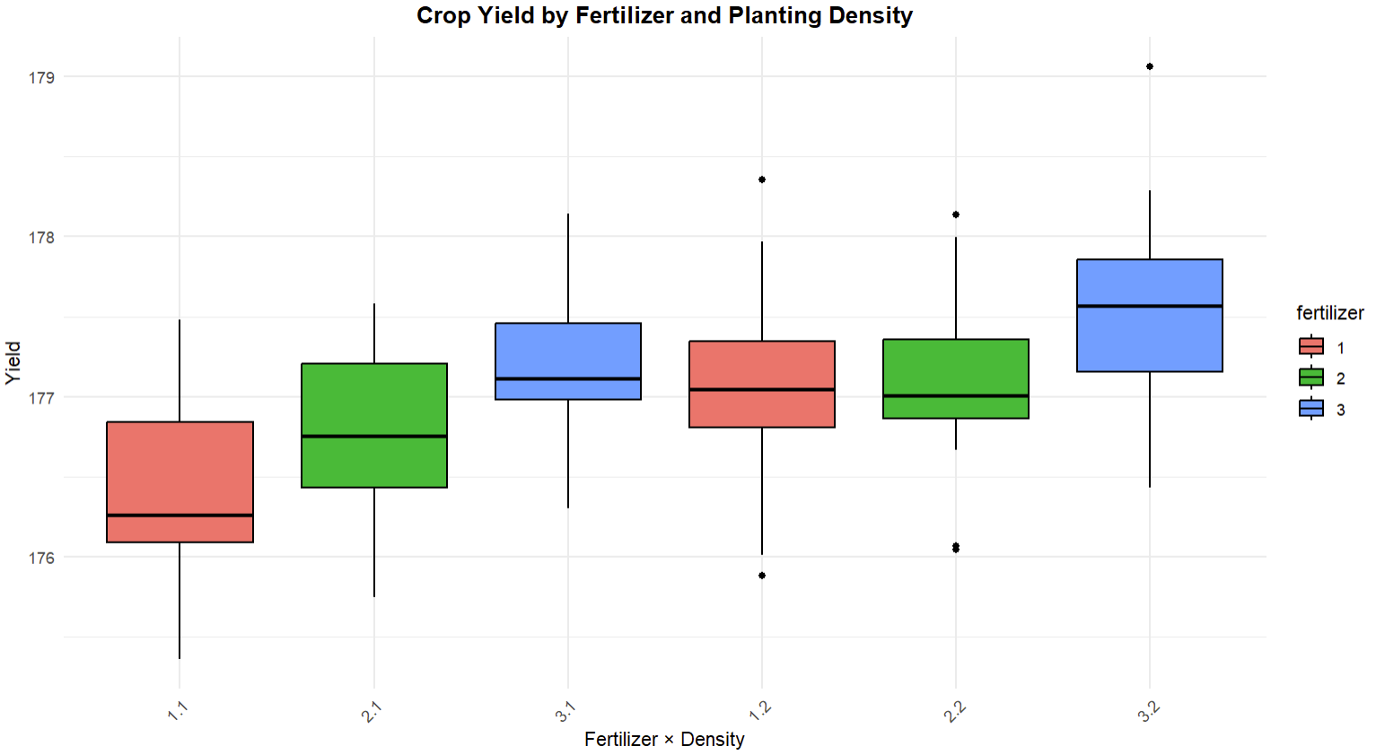

Conclusion

This report applied chi-square and ANOVA techniques to eight distinct analytical problems. Chi-square goodness-of-fit tests evaluated whether observed frequency distributions conformed to theoretical expectations for blood types and airline delays, while chi-square tests of independence assessed association between categorical variables in ethnicity-enrollment and military gender data. One-way ANOVAs compared means across food category sodium levels, product sales, and regional per-pupil expenditures, with Tukey HSD post hoc comparisons identifying specific pairwise differences. Two-way ANOVAs were applied to plant growth data and agricultural crop yield data to assess both main effects and interaction effects.
Across the analyses, 6 out of 9 null hypotheses were rejected at the α = .05 significance level. The strongest and most practically meaningful findings were the significant association between ethnicity and enrollment group (χ²(3) = 60.14, p < .001), the dominant effect of lighting on plant growth (F(1,8) = 24.56, p = .001), and the independent effects of fertilizer and planting density on crop yield — findings that carry direct implications for institutional policy and agricultural practice respectively. Non-significant results in sodium content, product sales, and regional expenditures are equally informative, suggesting that observed differences in those contexts are likely attributable to natural within-group variation rather than systematic effects. Notably, no interaction effects reached significance in either the plant growth or crop yield analyses, simplifying interpretation by confirming that each factor operates independently.
Together, these analyses demonstrate the breadth and utility of chi-square and ANOVA methods in applied analytics contexts. However, several limitations should be acknowledged. First, small sample sizes in Sections 12-1 and 12-2 (n = 4–8 per group) reduce statistical power, increasing the risk of Type II errors where real differences may go undetected. Second, the baseball chi-square analysis assumes equal expected wins across decades, which is unrealistic given league expansion — this reduces the interpretive value of that test. Third, the removal or absence of outlier checks across datasets may affect the robustness of ANOVA results, as ANOVA is sensitive to extreme values. Future work could strengthen these analyses by incorporating effect size measures such as Cramér's V for chi-square tests and η² (eta-squared) for ANOVA, and by exploring non-parametric alternatives such as the Kruskal-Wallis test where normality assumptions may be violated.
References
Bluman, A. G. (2018). Elementary statistics: A step-by-step approach (10th ed.). McGraw-Hill Education.
https://www.mheducation.com/highered/product/elementary-statistics-step-by-step-approach-bluman/M9781259696531.html

R Core Team. (2023). R: A language and environment for statistical computing. R Foundation for Statistical Computing.
https://www.r-project.org/

Wickham, H. (2016). ggplot2: Elegant graphics for data analysis. Springer.
https://doi.org/10.1007/978-3-319-24277-4

Wickham, H., Averick, M., Bryan, J., Chang, W., McGowan, L., François, R., Grolemund, G., Hayes, A., Henry, L., Hester, J., Kuhn, M., Pedersen, T., Miller, E., Bache, S., Müller, K., Ooms, J., Robinson, D., Seidel, D., Spinu, V., & Yutani, H. (2019). Welcome to the tidyverse. Journal of Open Source Software, 4(43), 1686.
https://doi.org/10.21105/joss.01686

Montgomery, D. C. (2019). Design and analysis of experiments (10th ed.). Wiley.

Agresti, A. (2018). Statistical methods for the social sciences (5th ed.). Pearson.
https://www.pearson.com/en-us/subject-catalog/p/statistical-methods-for-the-social-sciences/P200000003236

Appendix A: R Code
################################################################################
# Student Name: Nikita Mishra
# Date: 25-04-2026
# Course: Intermediate Analytics
# Section: 31
# ALY6015 - Module 2
################################################################################
################################################################################
# Load Required Libraries
################################################################################
required_packages <- c("tidyverse", "dplyr", "ggplot2")
install_if_missing <- function(pkg) {
if (!require(pkg, character.only = TRUE)) {
install.packages(pkg, dependencies = TRUE)
}
library(pkg, character.only = TRUE)
}
lapply(required_packages, install_if_missing)
#-------------------------------------------------------------------------------
# SECTION 11.1 - Blood Types
#-------------------------------------------------------------------------------
observed <- c(12,8,24,6)
expected <- c(0.20,0.28,0.36,0.16)
chisq.test(x = observed, p = expected)
barplot(observed,
names.arg = c("A", "B", "O", "AB"),
main = "Blood Type Distribution",
xlab = "Blood Type",
ylab = "Frequency",
col = "lightblue",
border = "black")
#-------------------------------------------------------------------------------
# SECTION 11.1 - Airlines
#-------------------------------------------------------------------------------
observed <- c(125, 10, 18, 40)
expected <- c(0.708, 0.082, 0.09, 0.12)
chisq.test(x = observed, p = expected)
barplot(observed,
names.arg = c("On Time", "NAS Delay", "Late Aircraft", "Other"),
main = "Flight Performance",
xlab = "Flight Status",
ylab = "Number of Flights",
col = "orange",
border = "black")
#-------------------------------------------------------------------------------
# SECTION 11.2 - Ethnicity vs Year
#-------------------------------------------------------------------------------
data <- matrix(c(724,335,174,107,
370,292,152,140),
nrow = 2, byrow = TRUE)
chisq.test(data)
#-------------------------------------------------------------------------------
# SECTION 11.2 - Women in Military
#-------------------------------------------------------------------------------
Data1 <- matrix(c(10791,62491,
7816,42750,
932,9525,
11819,54344),
nrow = 4, byrow = TRUE)
chisq.test(Data1)
#-------------------------------------------------------------------------------
# SECTION 12.1 - Sodium ANOVA
#-------------------------------------------------------------------------------
condiments <- c(270,130,230,180,80,70,200)
cereals <- c(260,220,290,290,200,320,140)
desserts <- c(100,180,250,250,300,360,300,160)
group <- factor(c(rep("Condiments",7),
rep("Cereals",7),
rep("Desserts",8)))
values <- c(condiments, cereals, desserts)
anova_model <- aov(values ~ group)
summary(anova_model)
boxplot(values ~ group,
col = c("lightgreen", "lightblue", "lightpink"),
main = "Sodium Levels by Food Category",
xlab = "Food Category",
ylab = "Sodium (mg)",
border = "black")
means <- tapply(values, group, mean)
points(1:3, means, col = "red", pch = 19)
#-------------------------------------------------------------------------------
# SECTION 12.2 - Sales ANOVA + Tukey
#-------------------------------------------------------------------------------
cereal <- c(578,320,264,249,237)
candy <- c(311,106,109,125,173)
coffee <- c(261,185,302,689)
group <- factor(c(rep("Cereal",5),
rep("Candy",5),
rep("Coffee",4)))
values <- c(cereal, candy, coffee)
sales_model <- aov(values ~ group)
summary(sales_model)
TukeyHSD(sales_model)
means <- tapply(values, group, mean)
barplot(means,
col = c("lightblue", "lightpink", "lightgreen"),
main = "Mean Sales by Category",
xlab = "Category",
ylab = "Mean Sales",
border = "black")
#-------------------------------------------------------------------------------
# SECTION 12.2 - Per-Pupil Expenditures
#-------------------------------------------------------------------------------
eastern <- c(4946,5953,6202,7243,6113)
middle <- c(6149,7451,6000,6479)
western <- c(5282,8605,6528,6911)
values <- c(eastern, middle, western)
group <- factor(c(rep("Eastern",5),
rep("Middle",4),
rep("Western",4)))
model3 <- aov(values ~ group)
summary(model3)
TukeyHSD(model3)
boxplot(values ~ group,
col = c("lightblue","lightgreen","lightpink"),
main = "Per-Pupil Expenditure",
xlab = "Region",
ylab = "Expenditure ($)",
border = "black")
#-------------------------------------------------------------------------------
# SECTION 12.3 - Plant Growth (Two-Way ANOVA)
#-------------------------------------------------------------------------------
growth <- c(9.2,9.4,8.9,8.5,9.2,8.9,
7.1,7.2,8.5,5.5,5.8,7.6)
light <- factor(rep(c("Light1","Light2"), each=6))
food <- factor(rep(c("A","B"), each=3, times=2))
data <- data.frame(growth, light, food)
plant_model <- aov(growth ~ light * food, data=data)
summary(plant_model)
interaction.plot(light, food, growth)
#-------------------------------------------------------------------------------
# SECTION 12.4 - Baseball Data (Chi-Square)
#-------------------------------------------------------------------------------
bb <- read.csv("baseball.csv")
bb$Decade <- bb$Year - (bb$Year %% 10)
wins <- bb %>%
group_by(Decade) %>%
summarise(wins = sum(W))
chisq.test(wins$wins)
ggplot(bb, aes(x = factor(Decade), y = W)) +
geom_boxplot(fill = "steelblue", color = "black") +
labs(
title = "Distribution of MLB Team Wins by Decade",
x = "Decade",
y = "Number of Wins"
) +
theme_minimal() +
theme(
plot.title = element_text(hjust = 0.5, face = "bold"),
axis.text.x = element_text(angle = 45, hjust = 1)
)
#-------------------------------------------------------------------------------
# SECTION 12.5 - Crop Data (Two-Way ANOVA with Block)
#-------------------------------------------------------------------------------
crop <- read.csv("crop_data.csv")
crop$fertilizer <- as.factor(crop$fertilizer)
crop$density <- as.factor(crop$density)
crop$block <- as.factor(crop$block)
model5 <- aov(yield ~ fertilizer * density + block, data=crop)
summary(model5)
ggplot(crop, aes(x = interaction(fertilizer, density), y = yield, fill = fertilizer)) +
geom_boxplot(color = "black") +
labs(
title = "Crop Yield by Fertilizer and Planting Density",
x = "Fertilizer × Density",
y = "Yield"
) +
theme_minimal() +
theme(
plot.title = element_text(hjust = 0.5, face = "bold"),
axis.text.x = element_text(angle = 45, hjust = 1)
)

